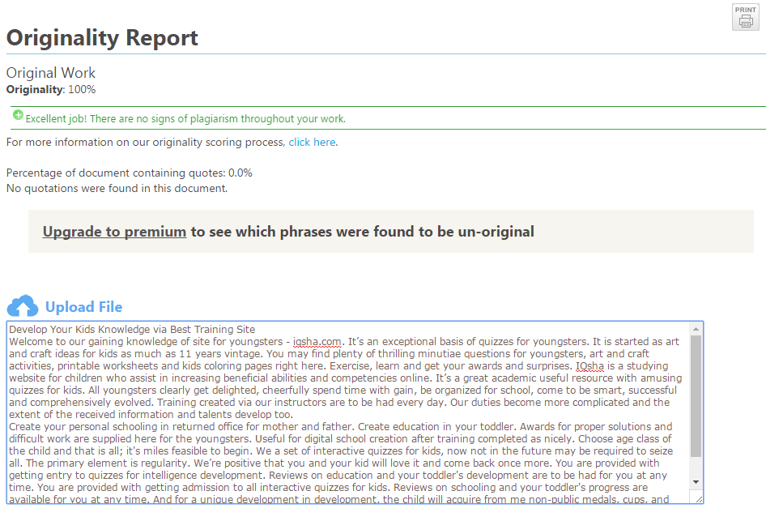
Develop Your Kids Knowledge via Best Training Site
Welcome to our gaining knowledge of site for youngsters - iqsha.com. It’s an exceptional basis of quizzes for youngsters. It is started as art and craft ideas for kids as much as 11 years vintage. You may find plenty of thrilling minutiae questions for youngsters, art and craft activities, printable worksheets and kids coloring pages right here. Exercise, learn and get your awards and surprises. IQsha is a studying website for children who assist in increasing beneficial abilities and competencies online. It’s a great academic useful resource with amusing quizzes for kids. All youngsters clearly get delighted, cheerfully spend time with gain, be organized for school, come to be smart, successful and comprehensively evolved. Training created via our instructors are to be had every day. Our duties become more complicated and the extent of the received information and talents develop too.
Create your personal schooling in returned office for mother and father. Create education in your toddler. Awards for proper solutions and difficult work are supplied here for the youngsters. Useful for digital school creation after training completed as nicely. Choose age class of the child and that is all; it's miles feasible to begin. We a set of interactive quizzes for kids, now not in the future may be required to seize all. The primary element is regularity. We’re positive that you and your kid will love it and come back once more. You are provided with getting entry to quizzes for intelligence development. Reviews on education and your toddler's development are to be had for you at any time. You are provided with getting admission to all interactive quizzes for kids. Reviews on schooling and your toddler's progress are available for you at any time. And for a unique development in development, the child will acquire from me non-public medals, cups, and diplomas.

